INFORMATION BOOKLET
Darraweit Guim PS
Building strong foundations for life….

Table of Contents
TABLE OF CONTENTS
Welcome 2
Staff Members 2
School Profile 2
What we offer 3
General Information 4
First Steps to Foundation – Transition Program 4
Attendance and Absences 4
Class Times 5
Behaviour 4
Homework 5
Car Parking 5
Assembly / Celebration Days 5
Child Safe Policy and Procedure 5
Immunisation 6
Parent Helpers 6
Parent Payments 7
Graduation 7
Lost Property 7
Newsletter 7
Emergency Management 7
School Council 7
School Uniforms 8
School Facebook Page 8
School Website 8
Sporting Program 8
Student Medical Plans 9
Sun Protection 9
Working Bees 9

Welcome
Thank you for considering Darraweit Guim Primary School as the preferred school for your child’s education path.
The staff and School Council are committed to delivering the highest educational opportunity for every child. We aim to create an environment where all members of the school community are valued and can work together in a co-operative manner. Enjoyment, success and lifelong learning are an integral part of school life.
Darraweit Guim Primary School has a unique school setting situated in a valley surrounded by farmland and boasts a supportive, positive and welcoming school community. The school’s large playground areas, which include an adventure playground, two sand pits, an oval and quiet sitting areas, allow students to play happily, supporting your child’s social and emotional wellbeing.
If you have any further queries, please do not hesitate to ask one of our friendly community school members.

STAFF MEMBERS

Mrs. Carol Booker | Principal
Mrs. Jane Nixon | Junior Class Teacher
Mr. Simon Boxall | Senior Class Teacher
Mrs. Meaghan Anders | French, Kitchen Garden
Mrs. Leigha Clark | Art
Mrs. Karen Ivory | Senior Class Aide
Mrs. Theresa Buffone | Junior Class Aide
Mrs. Jeanette Kalinski | Business Manager (Mon AM/Wed All day)

School Profile
Darraweit Guim Primary School is a small, vibrant, rural school. It is unique in its ability to offer individual attention to all students, small class sizes, as well as being very well resourced. We offer all of the advantages of a small rural school environment, whilst having the latest technology, and a caring and dedicated team of staff who are committed to supporting all students to achieve personal and academic success.
The school is located in the Darraweit Guim Township, less than a ten-minute drive from Wallan. Students are drawn from Darraweit Guim and the surrounding areas.
Our school values are: Be respectful, be honest, be caring & be willing to learn.

What we offer
All of our programs are purposefully designed to meet the needs of our students. We have a strong data focus to ensure we are able to cater to the needs of every student. We are proud to be able to say that we provide independent and individual goal setting for EVERY student in the school. All of our lessons are differentiated and engaging. With an average of 15 students per class, we are able to provide a personalised education for each and every child. Our students who require additional learning support work 1:1 or in small groups targeted to individual needs facilitated by our experienced educational support staff members and myself. We have introduced a SRC leadership group, including two school captains.
Ensuring your child becomes literate and numerate is our core business.
We provide a comprehensive English program for all children across the school. Our English program promotes the development of literacy skills through the provision of daily literacy sessions. These literacy sessions are non-interrupted learning time for children Foundation to Year 6. Students engage in a minimum of two hours of literacy daily.
Our reading program is based on the CAFÉ model, our writing includes the 6+1 traits of writing.
Our numeracy program aims to develop useful mathematical and numeracy skills for everyday life, work and as active and critical citizens in a technological world. It covers Number and Algebra, Measurement and Geometry & Statistics and Probability and has the four math’s proficiencies embed within. These proficiencies include: Understanding, Problem Solving, Reasoning and Fluency.
We use an inquiry approach to integrate curriculum areas such as history, geography, science etc. We aspire to develop students who will thrive in the new millennium and understand that students need to have greater thinking and problem solving abilities and be more self-motivated than ever before. Through this approach, we support and guide our students to be thinkers and enquirers, who wonder and pose questions.
Our Specialist programs are currently:
- Art
- Physical Education/Outdoor Education
- Language other than English (LOTE): French
- Kitchen Garden
The school seeks to provide a broad range of experiences and activities during the year, which both complement and enhance the curriculum.
- Excursions, which can be in Melbourne or local. We will often do walks around Darraweit Guim to explore our surroundings.
- Incursions to the school have been greatly received. This is where outside organisations visit the students at school.
- Camps – Year 3-6 students attend a three-day camp and the F-2 students experience a sleepover at school.

General Information

FIRST STEPS TO FOUNDATION – TRANSITION PROGRAM
The aim of our ‘FIRST STEPS TO FOUNDATION’ program is to ensure that future Foundation students have the best start and transition to formal schooling. The program consists of six scheduled school visits in which the children will participate in a variety of classroom and school activities.
This is a wonderful opportunity for children to get a taste of school life by enjoying engaging activities and make new friends prior to starting school.

Attendance and Absences
Darraweit Guim Primary School follows the concept of ‘It Is Not Ok to Be Away’. The school expects that all students attend school. We do though, understand that on occasions, children may be too ill to attend school. If a student is absent, the parent/carer must call the school as close to 9am to explain the student’s absence, then follow up with a written absence note or notification via the uEducateUs portal. Paper absence note templates are available from the Administration Office. To help facilitate a high level of attendance, it is best to organise appointments, and schedule activities for outside of school hours where at all possible.
Should you need to take your child out of school for an appointment – you are required to complete the sign in and out book that is located at the Administration Office. Similarly, when you return – you must resign the student into school.
If your child is going to be absent for some time from school – please make an appointment with the Principal to discuss.

BEHAVIOUR
Darraweit Guim Primary School encourages positive and inclusive behavior at all times. Our school values are RESPECT, CARING HONESTY AND WILLING TO LEARN. We have a zero tolerance to physical abuse and bullying.
Positive and responsible student behaviour is essential to the smooth running of the school, to the achievement of optimal learning opportunities, and to the development of a supportive and cooperative school environment.
We manage poor behaviour in a positive and professional manner and establish well-understood and logical consequences for student behaviour.
In implementing a positive behaviour environment, we will ensure that:
- Our Student Engagement and Inclusion Policy places significant emphasis on the development and recognition of positive behaviours.
- Student individual academic reports will include details regarding student behavioural achievement.
- Positive student behavioural achievement will appropriately recognised.
- An up-to-date database of student behaviour will be maintained.
- Students experiencing difficulty achieving positive behavioural outcomes will undertake individualised behaviour management programs focusing upon agreed goals.
- Parents will be kept informed, and actively encouraged to assist in the development of their children’s behavioural performance.
Further information on student discipline can be found in our Behaviour Management Policy & our Anti-bullying Policy and Procedure – which is available from the Administration Office, or on our school website.

class times
School is from 9am – 3.30pm. Children are supervised in the playground before school from 8.45am.
Children will also be supervised in the playground after school until 3.45pm. Please ensure that your child/ren are collected by this time. If you are running late – please phone the school to let us know.

homework
School homework is kept to a minimum. Weekly homework tasks are set and completed via the Google Classroom platform. Daily reading practice is highly recommended.
Each student will be given a reading satchel, which will be sent home every afternoon and should be returned to school the next day. This folder will contain a book, and a diary. The Diary will be used to record the name of the book, and to record teacher and parent/carer comments. The home folder will also be used for newsletters, permission forms and school work.
Children at school are provided with a book to take home and read each night. Parents are asked to ensure that these books are read, shared and that the reading diary is signed daily.
The purpose of home reading is for the children to practice their reading skills, to enjoy the reading experience and to share their progress as confident reader with their families.

Car Parking
The school has a carpark available to all parents/carers, at the side of the school. Extreme care is requested from everyone using the carpark. Children and siblings are unpredictable, so we ask that walking pace is maintained when driving in the car park and that all cars are reverse parked when picking up children.

ASSEMBLY / Celebration Days
A whole school assembly is held every Friday at 3.00pm. Our school leaders take turns to run the weekly assembly. This is held in the Blue Stone Building (during the colder months) or outside (during the warmer months). All parents, carers and friends are invited to attend. A student presents their work from both classes and selected students are presented with the Student of the Week award. Important notices are also announced. School is then dismissed at the conclusion of the assembly at 3.30pm.
Throughout the year, we will celebrate certain days with dress ups and special lunches. These include, but are not limited to: Book week theme days, Mothers and Father’s day celebration (and stalls), Easter bonnet parade and egg hunt, footy day, wheels day and an annual end of year concert.

Child Safe Policy and Procedure
The Darraweit Guim Primary School fundamentally believes that all children have the right to a life that is free from harm. Our school provides an environment that is free from any type of abuse and foster a child’s growth and development as per the individual requirements of each child.

Staff at our school are aware of their obligations under the law in regards to the welfare of children and at all times uphold their obligation. In addition to this, our school provides regular training to all staff on child protection issues to ensure that the school can act quickly in the best interests of the child if needed. All children enrolling at our school enjoy a smooth transition that enables them to become part of our school with a minimum of disruption and maximum support.

Our Child Safety policy and statement of commitment to child safety details:
- the principles that will guide the school in developing policies and procedures to create and maintain a child safe school environment; and
- the actions the school proposes to take to:
  - demonstrate its commitment to child safety and monitor the school's adherence to its child safety policy;
  - support, encourage and enable school staff, parents, and children to understand, identify, discuss and report child safety matters; and
  - support or assist children who disclose child abuse, or are otherwise linked to suspected child abuse
We have zero tolerance of child abuse. All allegations and safety concerns will be treated very seriously and consistently with our robust policies and procedures.

Further information can be found in our Managing the Risk of Child Abuse Policy and Procedure that is held in the Administration Office and it is also available on our website.

immunisation
All children must provide a history statement from the Australian Childhood Immunisation Register (ACIR), before enrolment can be completed. Booklets kept by parents cannot be accepted.
If the certificate / history statement has not been supplied to the school for a student, and there is an outbreak of disease (i.e.- measles, polio, diphtheria, whooping cough) then those students and non-immunised students will be directed that they are not to attend school for the period recommended in the exclusion table that is available at the Administration Office.
If your child/ren are not immunised – please discuss this with the Principal prior to completing enrolment.

parent helpers
We encourage all families to take an active role in the education of their children. Parents/carers are welcome to assist at the school in a variety of ways throughout the school year, and requests for help will be placed in the newsletter as necessary.
Some areas you may like to become involved in include hearing the children read, sports programs, art and craft activities, and gardening. If you have any special skills or interests please let us know.
All parents that assist at school must hold a current valid Working with Children’s Check.
We love to celebrate birthdays!! It is advised that if you would like to bring cupcakes or lolly bags for your child – please let the teacher know in advance. It is recommended that you provide enough cupcakes/lolly bags for your child’s grade. Numbers can be obtained from your teacher. Please do not provide anything with nuts in it.
We are currently involved in the Scholastic Australia book club scheme, which offers a wide variety of books at discount prices. The school receives free books for our library based on the quantity of books purchased throughout the year. Paper brochures will be sent home for parents to order books, throughout the year, if they wish. LOOP online orders are required. Order by dates will be advised via the school newsletter.

parent payments
Parent payments cover the cost of essential items used by your child during the year in the classroom. The levy is reviewed annually in term 4 for the following academic year. There are four options for payments of these fees: details of which will be outlined in a notice sent home to parents at the end of the year.
As a school we are able to purchase in bulk, enabling us to pass on the savings to our families, it also ensures that all students have the same supplies. Students receive their stationery pack on the first day of term 1. Parents are asked to name all items and send them all back to school. Requisites will be stored at school and given to the students as they need them.
2020 Parent Payment is $170-00.
When you are required to pay money to the school – you can do it one of three ways.
- Preferred method - EFT. PLEASE ensure that your child/rens details are listed in the description.
- Bpay - Individual Bpay codes are included on family statements.
- Cash – please make sure the money is in a sealed envelope with the details about the payment
on the front.
Payments are to be handed directly to the office. If the office is unattended please place the envelope in the locked ‘white’ box in the foyer.

Graduation
At the end of the year, our year 6 graduates enjoy a day out with their teacher and a graduation dinner. A photo story for each student is developed and shared and our graduates are presented with a certificate. Family and friends are invited to the dinner to celebrate this milestone.

Lost Property
Every year we acquire a surprising number of items in our Lost Property box. All articles of clothing found at school will be returned to their owner, where possible. Please ensure that you clearly name all articles of clothing.

Newsletter
Each week we distribute a school newsletter, usually on Thursday. A digital copy is sent out via uEducateUs and on the school website. If you have anything to go into the newsletter – please speak to Jeanette Kalinski in the Administration Office. We do try to keep advertising to a minimum. The newsletter is our main form of communication to parents about upcoming events and costs involved.

emergency management
The school has a comprehensive listing of emergency procedures that we follow. Our Emergency management Plan is updated annually and all emergency procedures are practiced throughout the year.
A copy the schools emergency procedures can be viewed on request.

School Council
Darraweit Guim primary School have an active School Council, which plays an important role in the schools operation and advancement. School Council consists of the principal, parents and staff, all working and planning together for the benefit of the school and its students.
School Council elections are held annually at the start of each new school year, and we encourage all parents to consider participating in this vital area of school administration. Appointments are for 2 years.

School Uniforms
Darraweit Guim Primary School requires all students to be in uniform when attending school.
School uniform orders are placed at least three times a year. The current school uniform is:
Winter
Boys | Girls
Navy blue pants / track pants | Navy blue pants / track pants
Long sleeve royal blue school top | Long sleeve royal blue school top
Navy or white skivvy | Navy or white skivvy
Navy school windcheater | Navy school windcheater
Navy school hooded windcheater | Navy school hooded windcheater
Plain navy windcheater or cardigan | Plain navy windcheater or cardigan
Navy school bomber jacket | Navy school bomber jacket
Black shoes / runners | Black shoes / runners
Summer
Boys | Girls
Navy blue shorts | Navy blue shorts
Short sleeve royal blue school top | Short sleeve royal blue school top
Plain navy or white t-shirt | Plain navy or white t-shirt
Navy school windcheater | Navy school windcheater
Navy school hooded windcheater | Navy school hooded windcheater
Plain navy windcheater or cardigan | Plain navy windcheater or cardigan
Black shoes / runners | Navy and white check school dress
Navy school hat | Navy school hat
 | Navy skorts
 | Black shoes / runners
** Please note – where it mentions ‘school’ above – this means with the printed school logo. These uniform articles are available through the administration office.
Hats are compulsory during terms 1 & 4. Each student will be issued with a Navy school hat on their first day of school
Thongs and open toes sandals are not suitable footwear. Gumboots are a useful alternative in wet weather, and slippers can be worn in the classroom.

School Facebook Page
Our school has Facebook & Instagram pages - https://www.facebook.com/dgps0878/ https://www.instagram.com/darraweitguimps.0878/

School Website
Darraweit Guim Primary School has our own website. This can be found at http://www.darraweitguimps.vic.edu.au. Information is constantly updated and many of our Policies and Procedures can be found here.

Sporting Program
At Darraweit Guim Primary School, we run specialist physical education sessions for each class on a weekly basis. All students are encouraged to be involved. We also hold a combined sporting day with Bolinda Primary School during the year. Sporting activities are also encouraged during lunchtime breaks and sporting equipment can be borrowed for this.

Student Medical Plans
If your child has a medical condition that may impact their learning experience or require treatment from staff, a Medical Plan must be completed and this is then displayed in the staff room. The plan will detail what the conditions are, treatment to be given or sought if required and after care of student.
Please ensure that one is completed prior to as close to your child/ren starting school as possible.

Sun Protection
We are a sunsmart school and promote active protection from the sun. All children and staff are required to wear a sun smart hat when outside during terms 1 & 4. Children without a hat will be required to remain under the covered areas so that they are protected from ultra- violet rays. All students will be given a school hat at the commencement of their enrolment. Students are also asked to bring their own sunscreen. Hats remain at school during Terms 1 and 4. (They can be taken home on request for cleaning)

Working Bees
The maintenance of the school grounds is predominantly voluntary. Working bees are held and parent volunteers are welcome to assist wherever possible. It is a lovely way for our school community to work together to achieve the best possible surrounds for our children’s education and models to our children the values of team work and cooperation within the community.

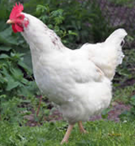
Our two resident chooks, Faith and Rose love to welcome new faces to our school. They have free range of our school grounds throughout the day and provide us with eggs that we sell to fund our garden projects.
We welcome tours by appointment. Just give us a call and we can arrange a convenient time.

Looking forward to meeting you - Carol Booker (Principal)

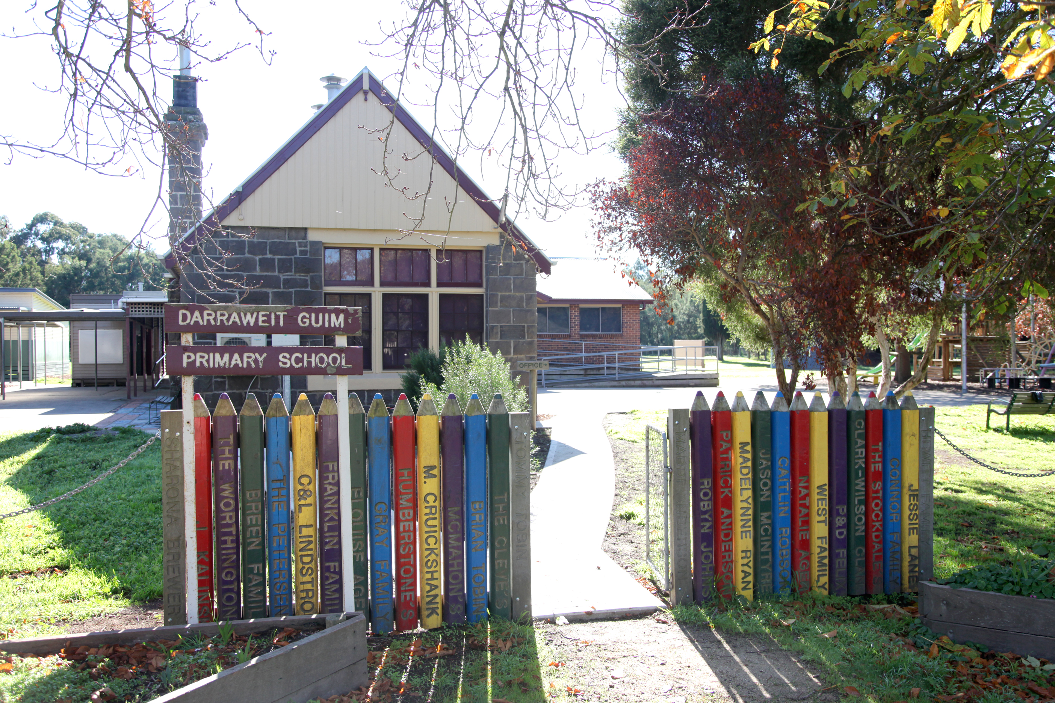

Darraweit Guim Primary School
2 Darraweit Valley Road
Darraweit Guim VIC 3756
Phone: 03 5789 1234
Web: http://www.darraweitguimps.vic.edu.au/
Email: darraweit.guim.ps@education.vic.gov.au
Facebook: https://www.facebook.com/dgps0878/

